8) Difference between Vertical Scaling and Horizontal Scaling

Interview Answer
“Vertical scaling means increasing the resources of an existing server, whereas horizontal scaling means adding more servers or instances to distribute the workload.”
Vertical Scaling | Horizontal Scaling
Scale Up | Scale Out
Increase CPU/RAM of one server | Add more servers/instances
Same server becomes more powerful | Workload is distributed
Example: 4 CPU → 8 CPU | Example: 1 server → 3 servers

Example
Vertical:
Before After

Server Same Server
4 CPU 8 CPU
8 GB RAM → 16 GB RAM
Horizontal:
Load Balancer
/ | \
↓ ↓ ↓
Server 1 Server 2 Server 3

Easy Memory Trick
Vertical = UP → increase power
Horizontal = OUT → increase servers
This matches the source's distinction between increasing the power of one machine and adding more machines/instances.

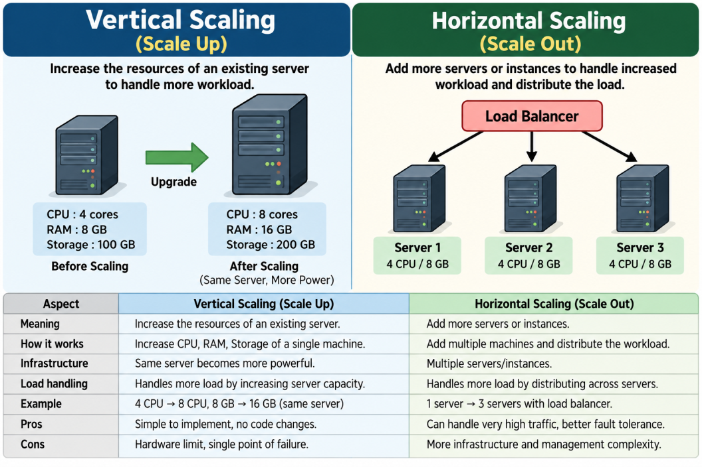

what is fault tolerance and single point of failure in simple terms
